**Factors to take into consideration for Creating ec2 instances**

* Every EC2 instance we create has some purpose i.e. for using it for
  + Web Servers i.e. hosting web sites
  + Databases Servers i.e. storing data
  + Cache Servers i.e. remembering data in memory
  + i.e. for running some applications
* Applications have different needs, AWS Helps by giving purpose based selections [Link: <https://aws.amazon.com/ec2/instance-types/> ]
  + General Purpose
  + Compute Optimized
  + Memory Optimized
  + Storage Optimized
  + Accelarated Computing
* Instance Families: Each Instance family has a specialized hardware. Here we will also have versions/Generations. Each Instance family is denoted by first character in your instance size. Instance Family is hardware spec of the physical server in the AWS AZ’s on which we create ec2 instances
  + t2.micro => instance family is t and 2 represents generation.
  + C5.xlarge => instance family is C and generation is 5
* Sizes: Each size represents number of cpu’s and RAM size, Network speed.
  + nano
  + micro
  + small
  + large
  + xlarge
  + 2xlarge
* Instance Type => Purpose + Family + Size
  + t2.micro
  + c5.4xlarge

Storage options virtual disk options: EC2 and disk should be from the same AZ.

* + Disks that get created from the same physical server
    - When we shutdown the instance, data will be wiped away
    - These disks are referred as instance stores. [They are supported only on some instance types.]

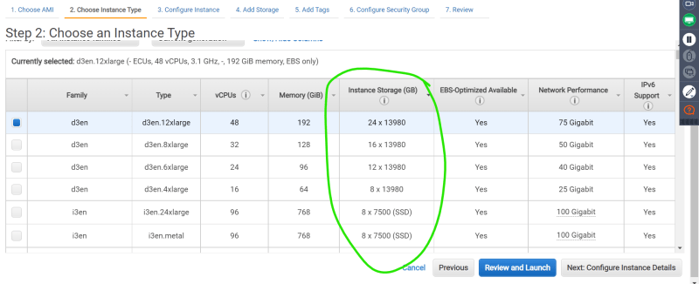  
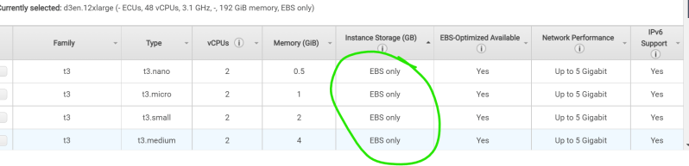

Disks that get created from the different physical server

When we shut down or even remove the instance, we can still have the disk and its contents In AWS, the disk which has operating system is always from a different physical server in the same AZ. These disks are referred as Elastic Block Storage (EBS).

EBS is supported in all the instance types.